Prepared By:

Chiranjeevi (1401),

S.E.

C:\Users\chiranjeevi.g\Downloads\image001.png

**LVM Creation Guide**

**Logical Volume Management:**

LVM stands for Logical Volume Management. It is a system of managing logical volumes, or filesystems that is much more advanced and flexible than the traditional method of partitioning a disk into one or more segments and formatting that partition with a filesystem.

**The Basics**

There are 3 concepts that LVM manages:

* Physical Volumes
* Volume Groups
* Logical Volumes

A *Volume Group* is a named collection of physical and logical volumes. Typical systems only need one *Volume Group* to contain all of the physical and logical volumes on the system, and I like to name mine after the name of the machine. *Physical Volumes* correspond to disks; they are block devices that provide the space to store logical volumes. Logical volumes correspond to partitions: they hold a filesystem. Unlike partitions though, logical volumes get names rather than numbers, they can span across multiple disks, and do not have to be physically contiguous.

**Installation**

In this guide, we will create LVM on RHEL server and share a disk partition with multiple servers.

**LVM Server**

To create a LVM partition we need to first setup the LVM server and create PV, LV and VG on that LVM server.

We will create PV at the time of creation of the VM and VG, LV after Vm creation. The steps as follows:

**VM Creation:**

1) Create New VM and choose Typical option to create VM with our own configurations

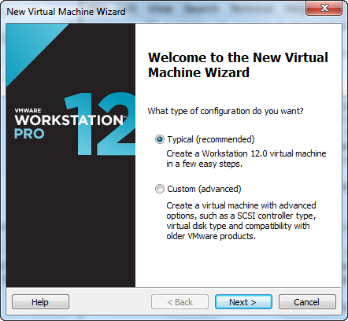

2) Choose lat option to create VM without any OS. It is advisable for the HDD partition while creating VM.

Click on “**I will install the operating system later**” and click **Next.**

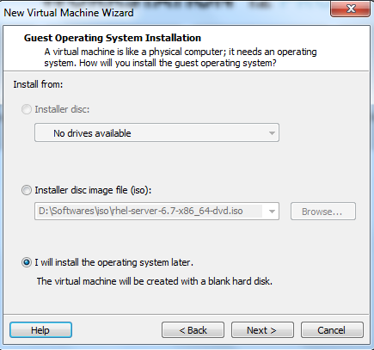

3)Select Linux operating system to be created as VM

Select Linux and click **Next**.

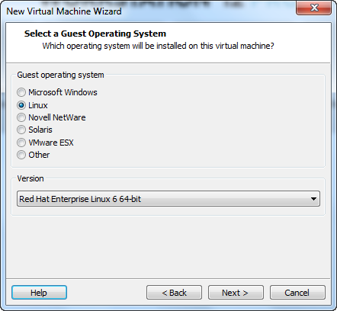

4) Provide the VM name and location to save that and click **Next**.

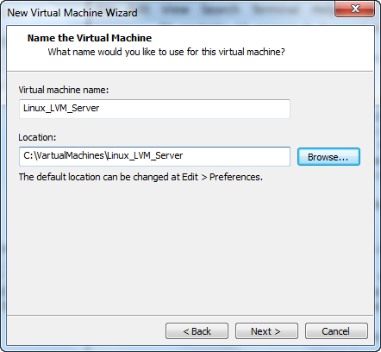

5)Provide disk space and select Store virtual disk as a single file option

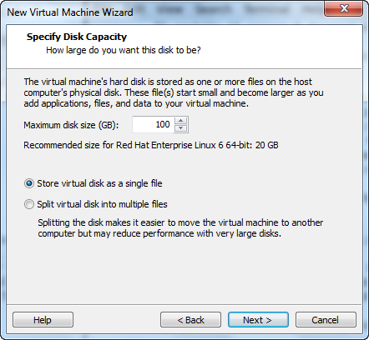

6) Click on Customize Hardware option to configure network adapter , MAC address and to browse for operating system .iso file

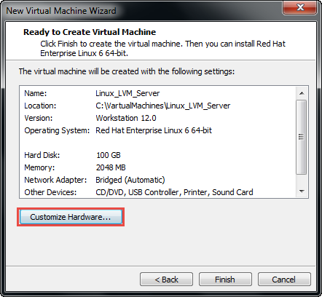

7) Select Network Adapter and choose Network Connection as Bridge connectivity 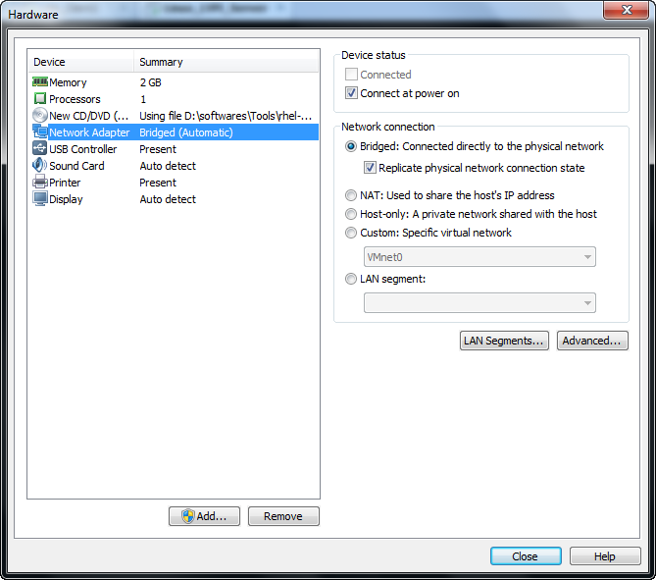

8) Click on Advanced option for Network adapter and generate new MAC address and add this MAC address to the network to get internet and to communicate with other systems in the network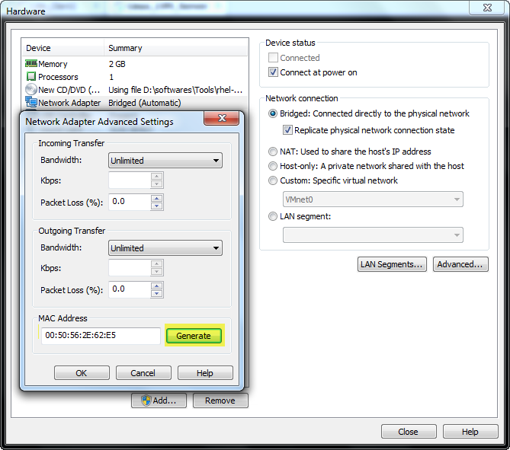

9) Browse for linux operating system .iso file in the SATA device option 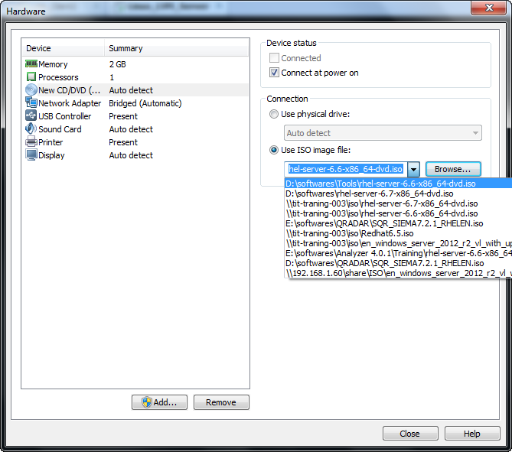

10)Select install an existing system option to start installing the Linux VM with our existing configurations

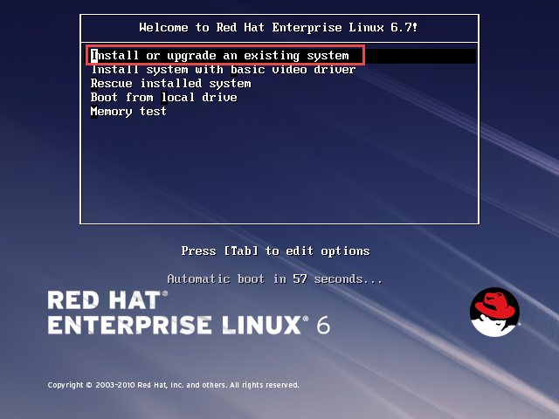

11)Skip the testing of installation media for errors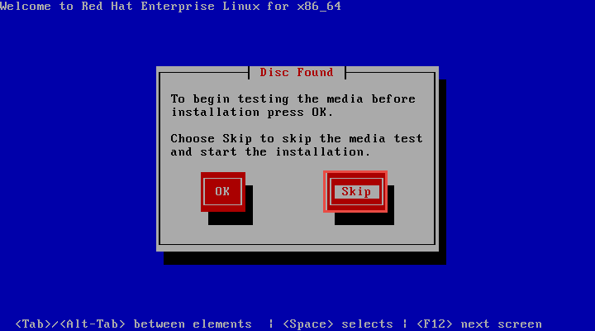

12)Click on **Next** to proceed RedHat Linux VM creation

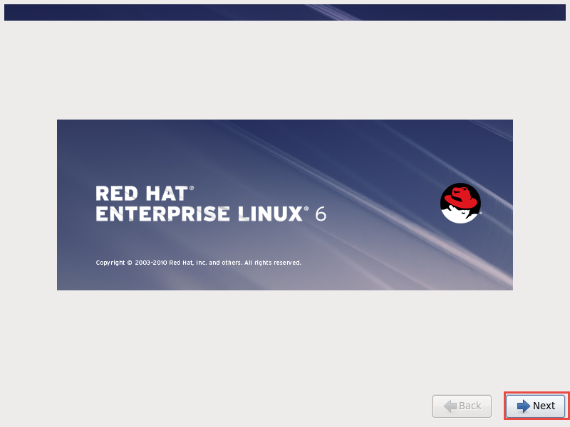

13)Choose English option for language settings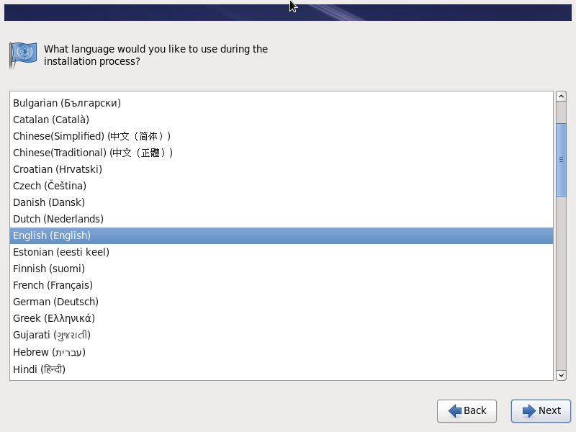

14)Choose U.S English for keyboard settings 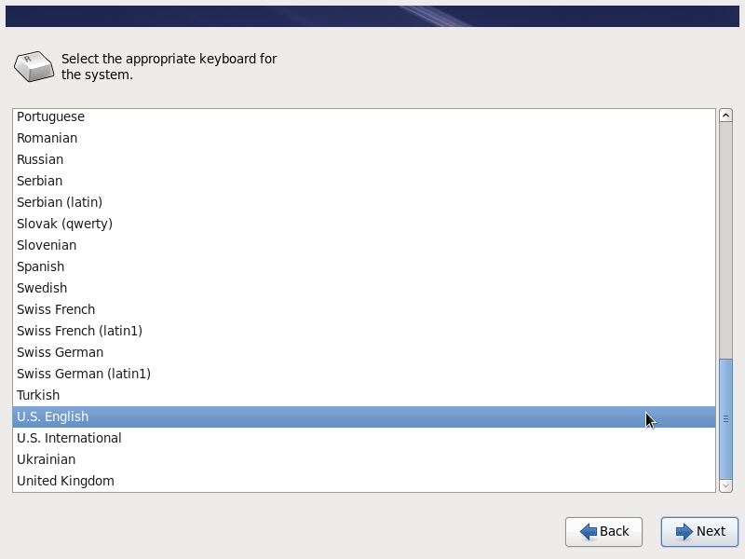

15)Click on Yes to discard any data to format on the disk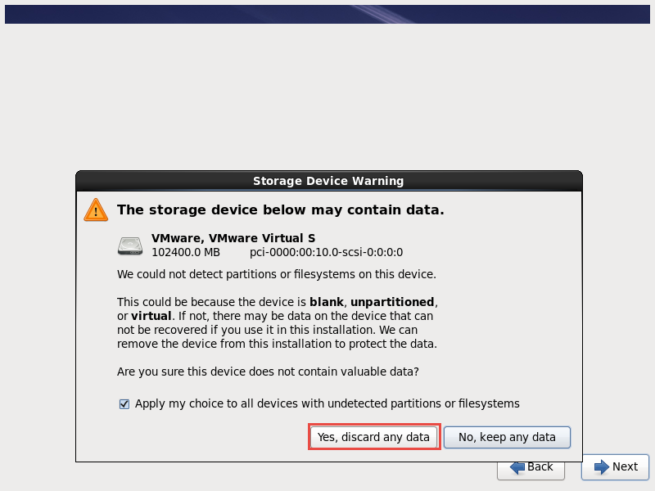

16)Keep localhost as default hostname , later if you want you can change in /etc/hosts file

Click Next to proceed VM creating 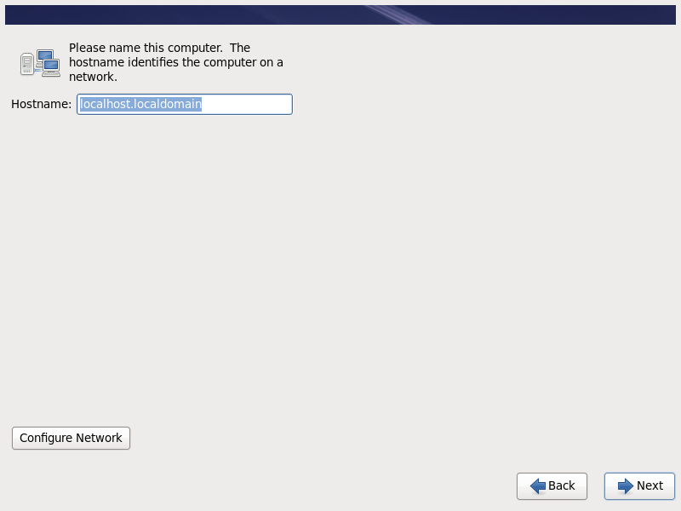

17)Select TimeZone settings

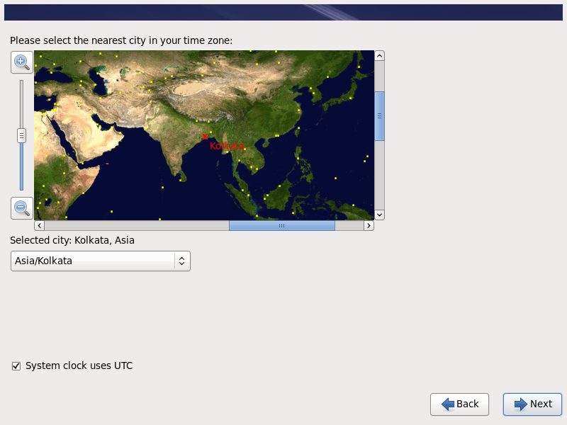18)Give password for Root user of the VM

Click on Use AnyWay for weak password 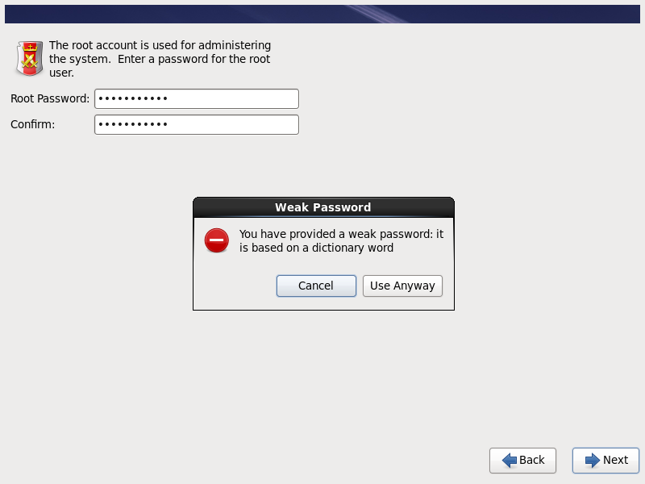

19)Choose Create Custom Layout for for disk partition 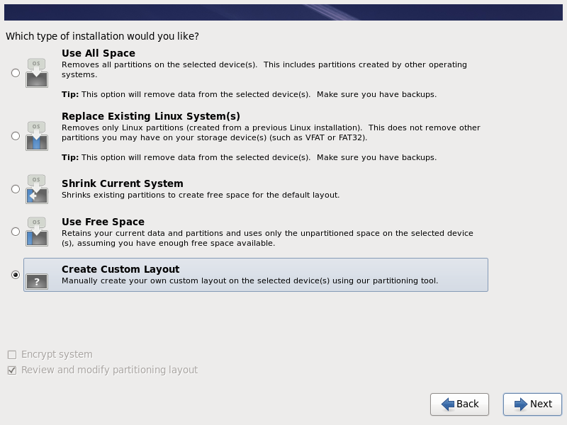

20) Create disk partitions for the OS bootable drive ,swap memory and for LVM drive 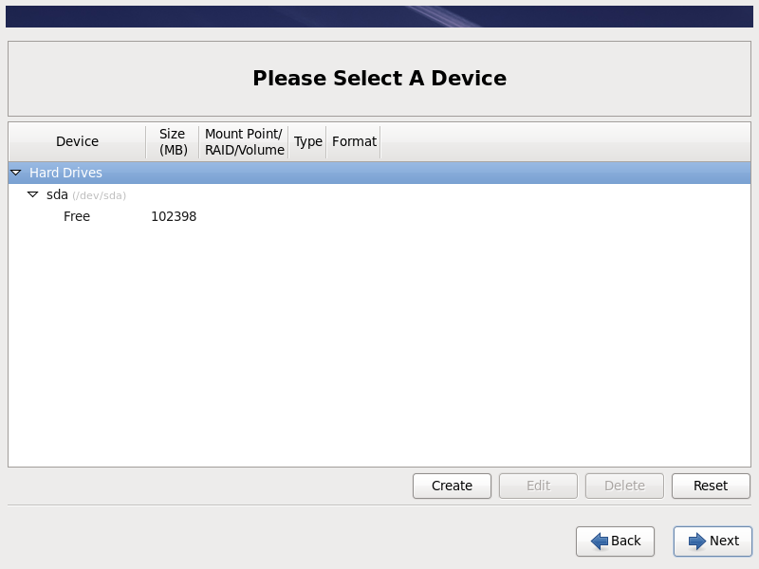

21) Choose **Standard partition** option to **create** standard disk partition

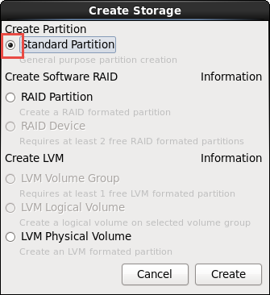

22) Create boot partition by select **/boot** Mount point for OS bootable drive as ext4 file system type and click ok to proceed 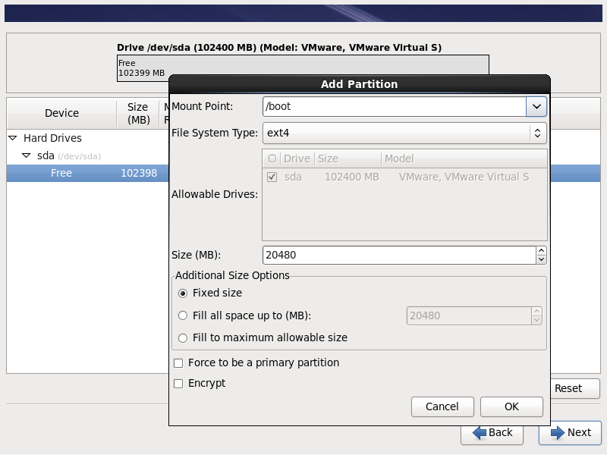

23) Choose **Standard partition** option to **create** standard disk partition as step 21



24) Choose **Standard partition** option to **create** standard disk partition as step 21



25)Create external partition by select / for the external storage 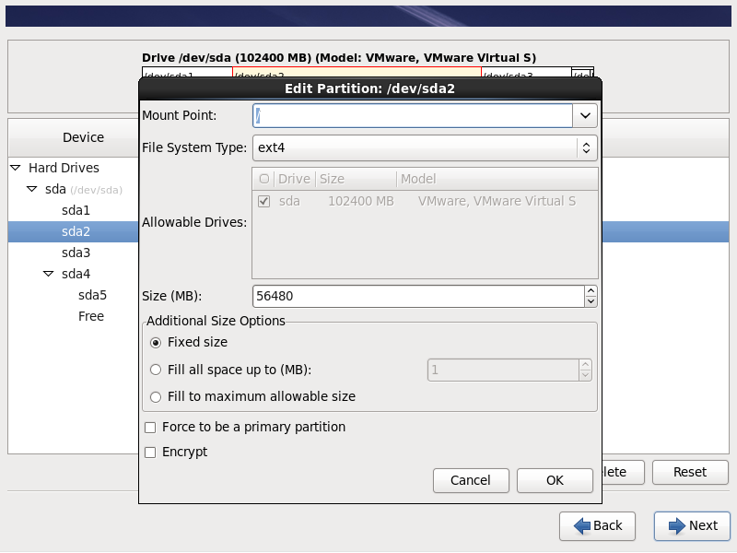

26)Create **SWAP** partition by selecting file system type as **swap** to provide extended memory space for RAM

Note: Provide swap memory as double the RAM 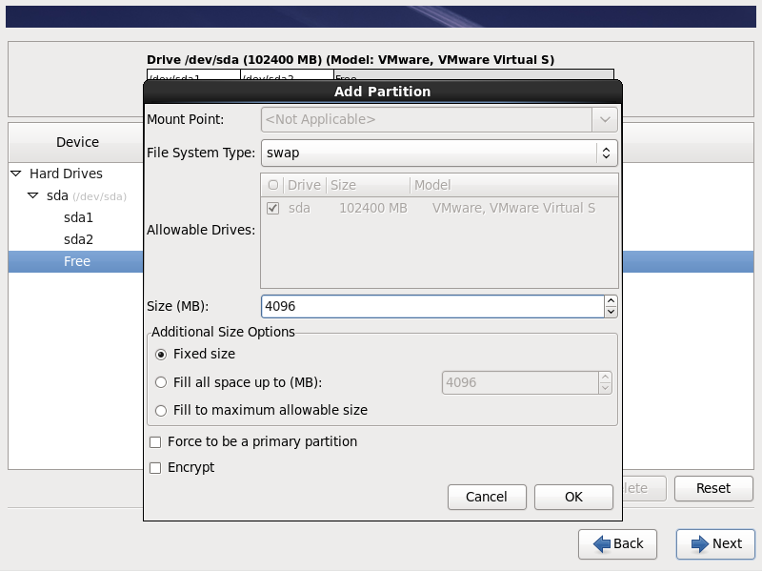

27) Choose **LVM Physical Volume** option to **create** LVM(Logical volume manager) disk partition

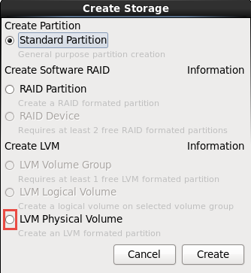

28) Create LVM physical volume partition by selecting physical volume (LVM) option and click ok. 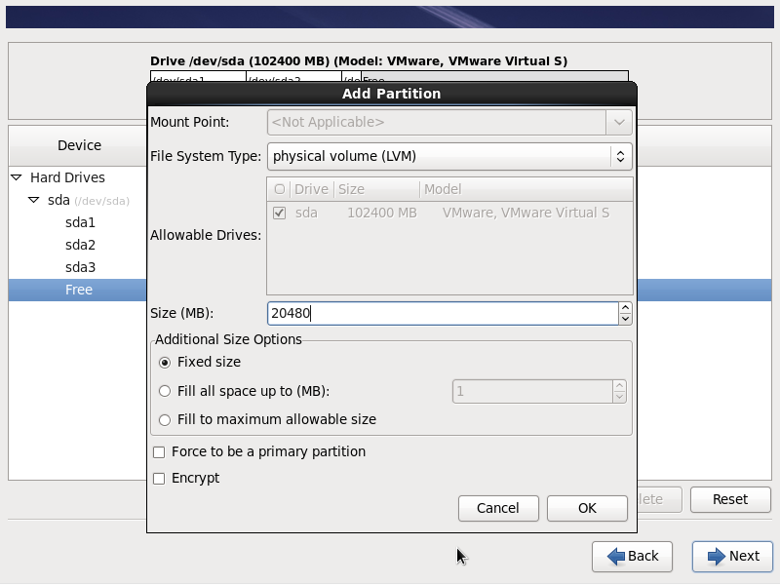

29)Click on **Next** once you have done with the disk partitions 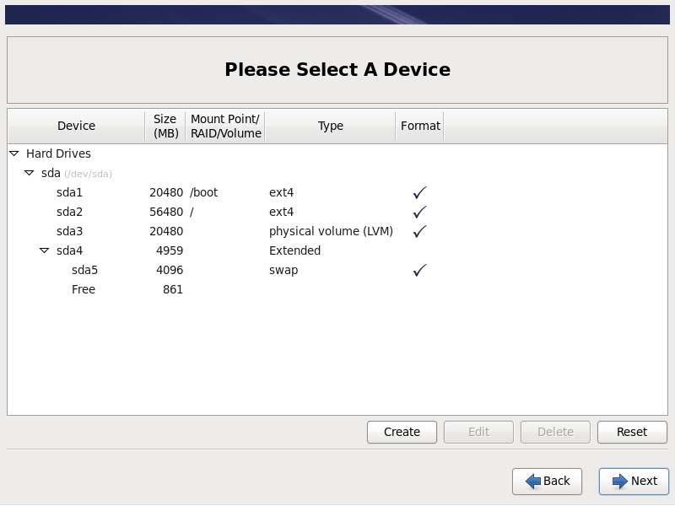

30)Click on Format option for the HDD to be cleaned before creating disk partitions. 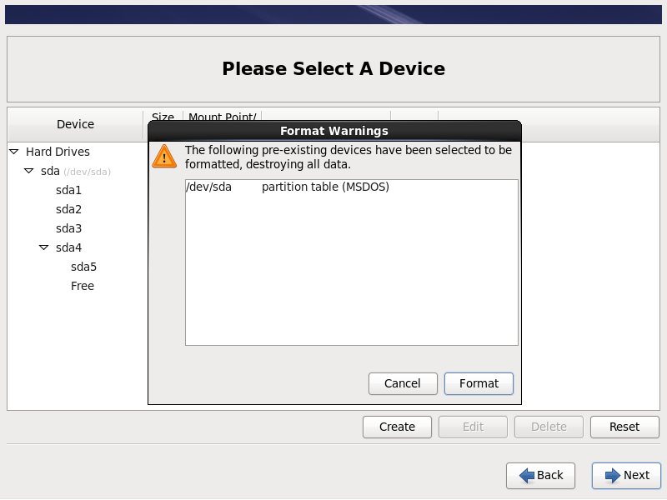

31)Click on write change to disk for the partitions to be written on HDD 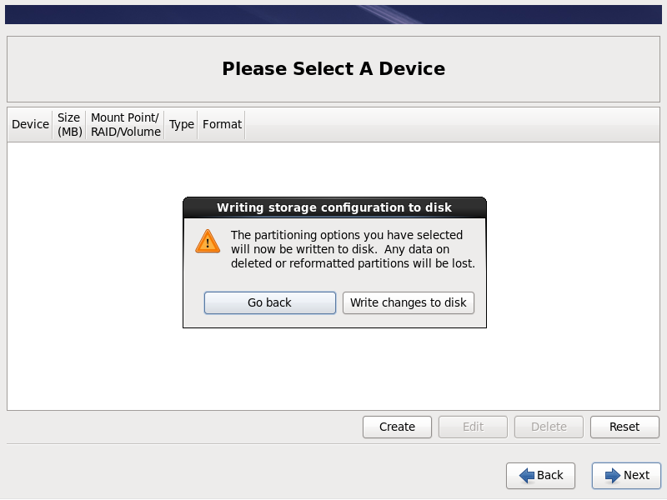

32)Select boot loader operating system for the respective /boot disk drive 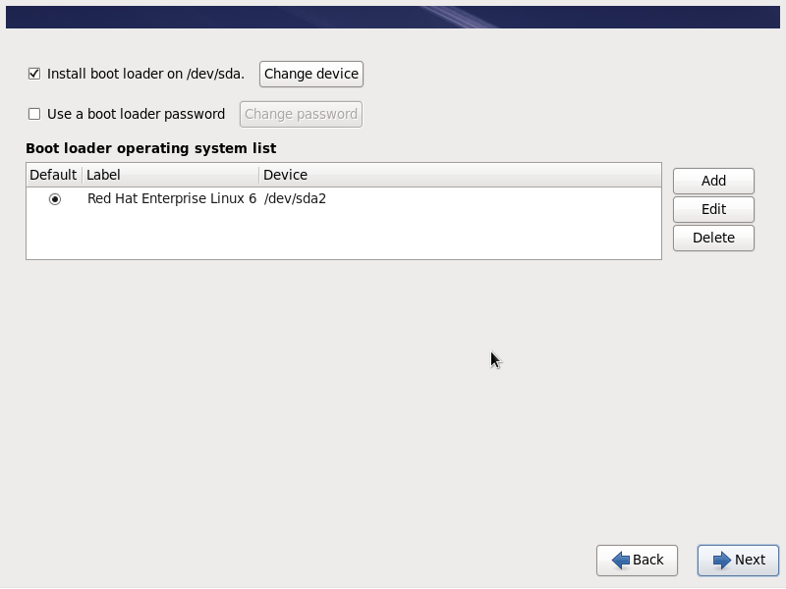

33)Choose **Desktop** type for the installation of RedHat linux operating system. 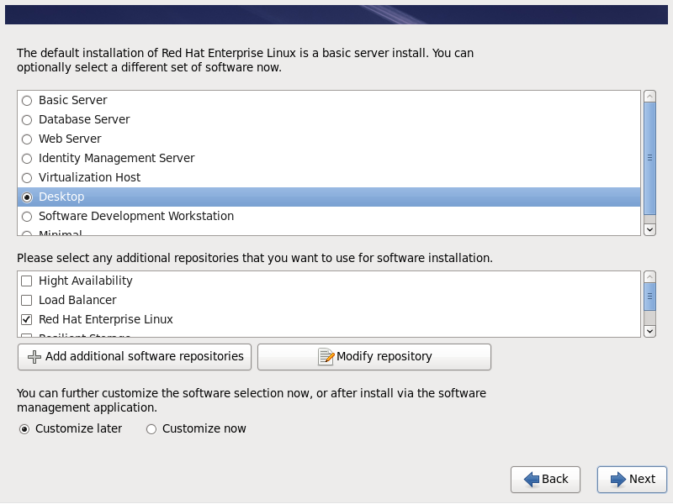

34)Click on **Reboot** for the Configurations to be written on disk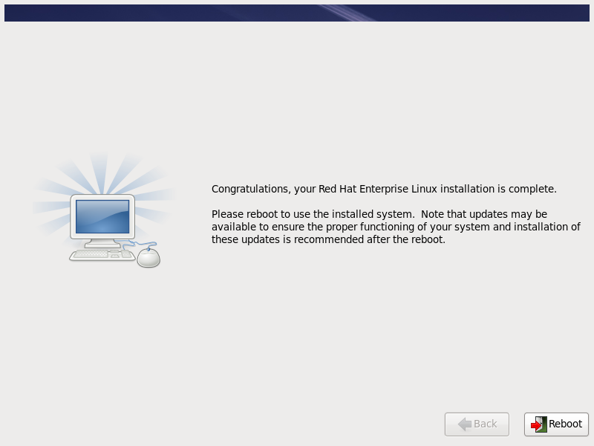

**Post VM creation tasks**

35) Click on **Forward** to proceed with the post VM creatin tasks.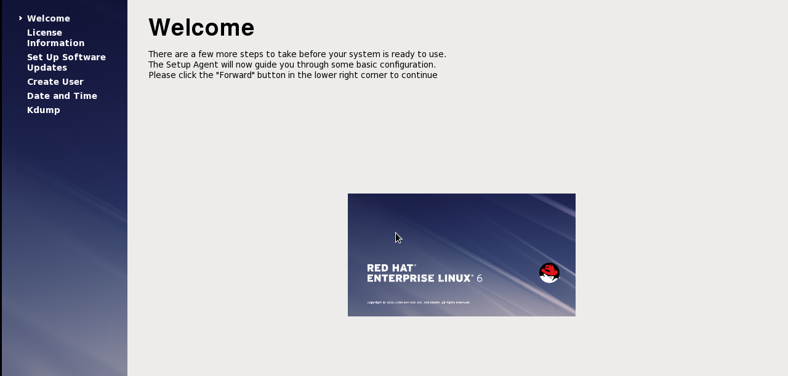

36)Click on Yes to agress with the RedHat Linux license agrement adn click forward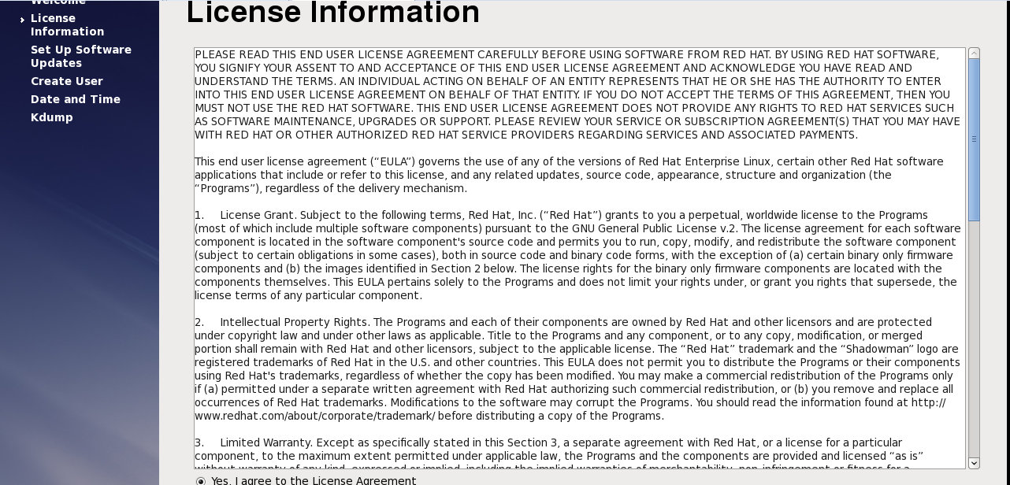

37) Setup software updates to be registered later time and click forward 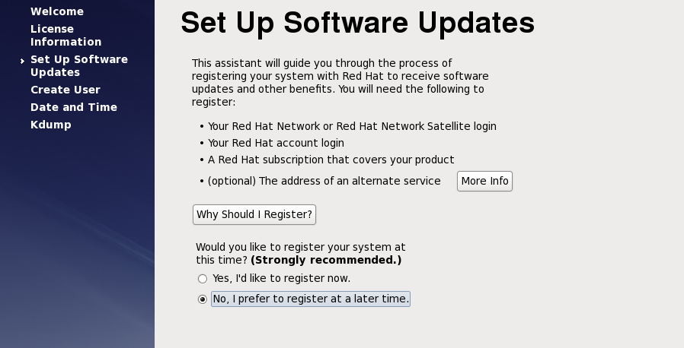

38) Click on **Register later** time for software updates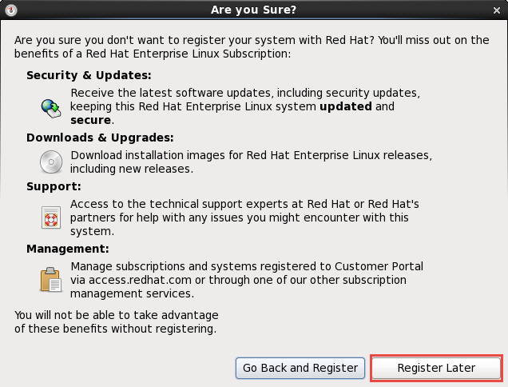

39) Click on forward to finish updates setup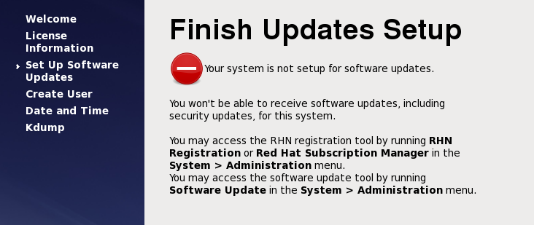

40) Create user for operating system configurations.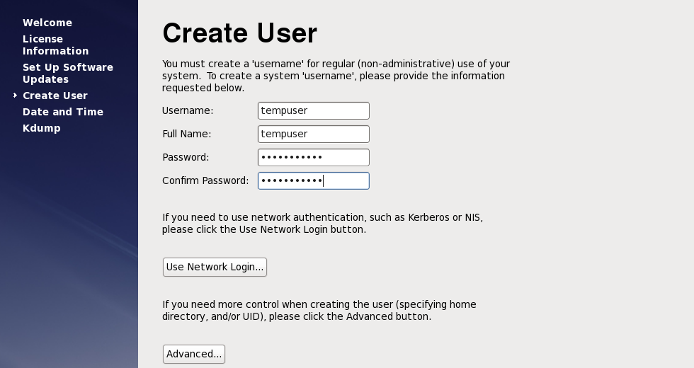

41) Click Yes for the weak password to be taken if anyway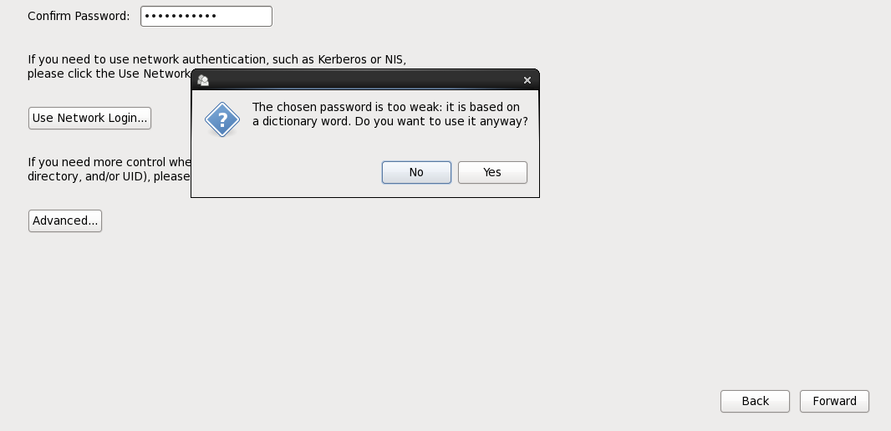

42) Tick the synchronize date and time over the network to synchronize with network.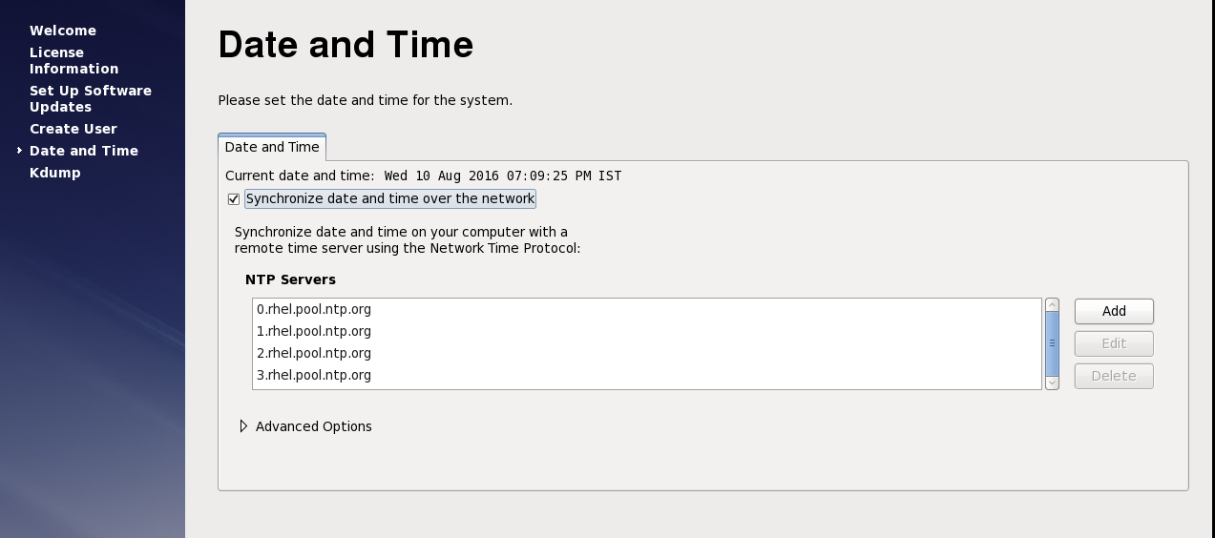

43) Click on forward option for Kdump in case on kernel crash dumping mechanism.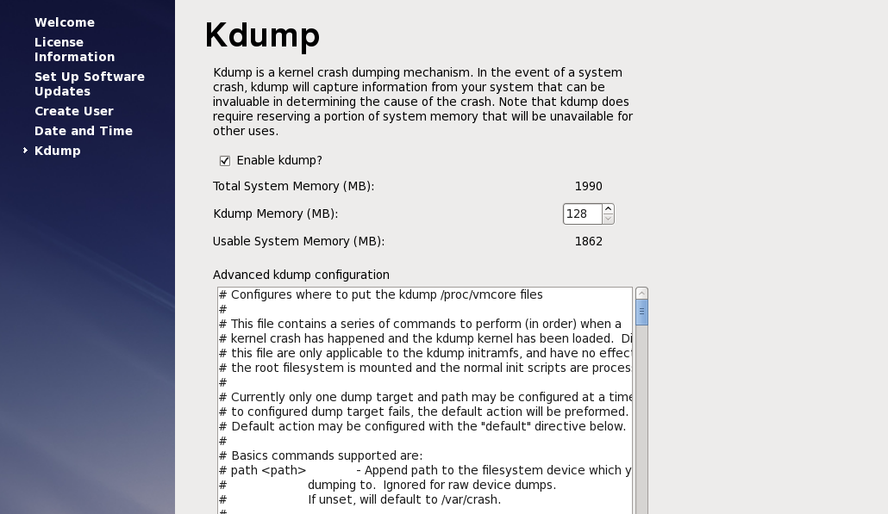

44) Click on fish and then ok to finish OS installation.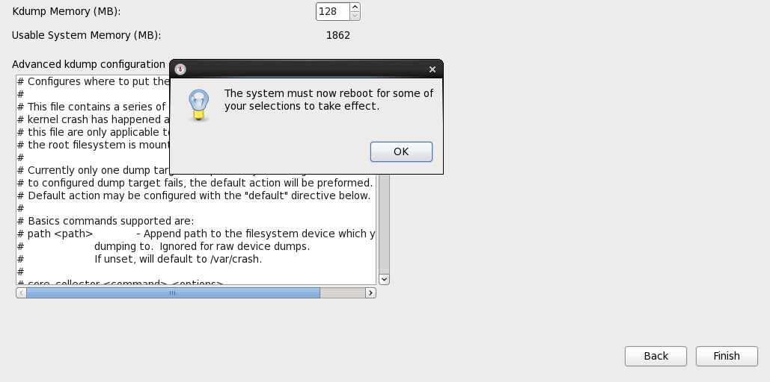

**On LVM server and On LVM Clients**

1. Mount the rhel-server-6.6-x86_64-dvd.iso file to the system.   
2. Select open a terminal window as a root.  
3. Execute the commands:   
[root@localhost]# mkdir /mnt/cdrom  
[root@localhost]# mount -o ro /dev/cdrom /mnt/cdrom  
4. Create the text file server.repo in the /etc/yum.repos.d directory.   
Note: To use gedit, execute the command:

[root@localhost]# gedit /etc/yum.repos.d/server.repo  
Add the following text to the file:   
  
[server]  
name=server  
baseurl=file:///mnt/cdrom/   
enabled=1  
  
where baseurl depends on the mounting point and the RHEL distribution.   
  
In the example, the mounting point is cdrom and the RHEL distribution is Workstation but could be sever.  
  
5. Execute the command:  
[root@localhost]# yum clean all  
6. Execute the command to import related public keys:  
[root@localhost]# rpm --import /mnt/cdrom/*GPG*  
7. Execute the commands to install the required libraries:  
[root@localhost]# yum install gtk2.i686  
[root@localhost]# yum install libXtst.i686  
If you received the missing libstdc++ message above, install the libstdc++ library:  
[root@localhost]# yum install compat-libstdc++  
yum install the following libraries as well

* yum install audit-libs.i686
* yum install audit-libs.x86_64
* yum install compat-libstdc++*i686
* yum install dos2unix.x86_64
* yum install gettext.x86_64
* yum install glibc.i686
* yum install glibc.x86_64
* yum install ksh.x86_64
* yum install libaio.i686
* yum install libaio.x86_64
* yum install libgcc.i686
* yum install libgcc.x86_64
* yum install libstdc++.i686
* yum install nss-softokn-freebl.i686
* yum install nss-softokn-freebl.x86_64
* yum install ntp.x86_64
* yum install openssh-clients.x86_64 pam.i686
* yum install pam-devel.i686
* yum install pam_passwdqc.x86_64
* yum install tcsh.x86_64 unzip.x86_64
* yum install xorg-x11-xauth.x86_64
* yum install zlib.i686 zlib.x86_64
* yum install gtk2.i686 gtk2.x86_64
* yum install gtk2-engines.i686
* yum install gtk2-engines.x86_64 libXtst.i686
* yum install libXtst.x86_64
* yum install nfs-utils

During the install you might receive prompts similar to the example. Answer with 'y'.

**Note:**

For LVM, We need to install an additional network storage server library

Command: yum groupinstall “Network Storage Server”

And install iscsi initiator utilities rpm file

Command: rpm -ivh /root/Desktop/iscsi-initiator-utils-6.2.0.873-21.el6.x86_64.rpm

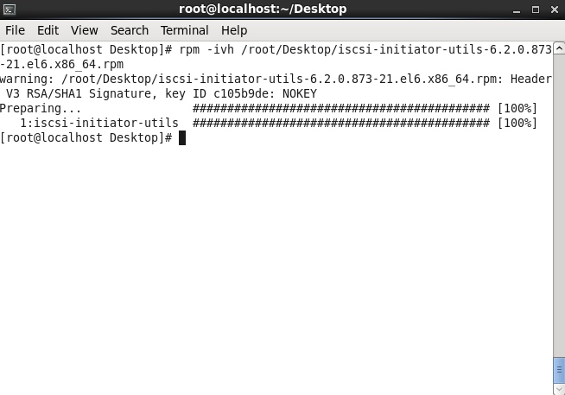

Do the following steps on all lvm server and Clients.

1. Open a terminal window, and log on as a root user.
2. Define a fully qualified name and short host name either by using a DNS server, or by creating a definition in the /etc/hosts file.
3. Ensure that the HOSTNAME value that is defined in the /etc/sysconfig/network file is set to the short host name, and that it is not set to the fully qualified host name. For example, set HOSTNAME=xyz instead of HOSTNAME=xyz.yourco.com.
4. Verify that the host name, fully qualified host name, and domain name are configured correctly on each server:
   * Enter the following command: hostname -s. The verification is successful if the command returns the defined short host name for the server.
   * Enter the following command: hostname -f. The verification is successful if the command returns the fully qualified domain and host name for the server.
   * Enter the following command: hostname -d. The verification is successful if the command returns the domain name of the server.
5. In the /etc/selinux/config file, configure the SELinux setting to either permissive or disabled. For example, to configure the SELinux setting to permissive, in the /etc/selinux/config file, edit the SELinux setting as shown in the following example and then restart the server:

SELINUX=permissive

Note: The SELinux setting must not be enabled.

1. Reboot the operating system using the following command to make the SELinux changes effective:

reboot

1. To disable the server firewalls, enter the following commands:

service iptables save

service iptables stop

chkconfig --level 123456 iptables off

1. To install the prerequisite RPM files, enter the following command:

**yum install -y audit-libs.i686 audit-libs.x86_64 compat-libstdc++*i686 compat-libstdc++_*x86_64 dos2unix.x86_64 gettext.x86_64 glibc.i686 glibc.x86_64 ksh.x86_64 libaio.i686 libaio.x86_64 libgcc.i686 libgcc.x86_64 libstdc++.i686 nss-softokn-freebl.i686 nss-softokn-freebl.x86_64 ntp.x86_64 openssh-clients.x86_64 pam.i686 pam-devel.i686 pam_passwdqc.x86_64 tcsh.x86_64 unzip.x86_64 xorg-x11-xauth.x86_64 zlib.i686 zlib.x86_64 gtk2.i686 gtk2.x86_64 gtk2-engines.i686 gtk2-engines.x86_64 libXtst.i686 libXtst.x86_64 nfs-utils**

1. Install the Red Hat Enterprise Linux packages for the X Window System on the analytics, application, and web servers.

X Windows is not required for the initial installation of IBM Intelligent Operations Center, but it is required if you want to update the underlying IBM products by using IBM Installation Manager. For example, you can update WebSphere Application Server Liberty Profile and IBM HTTP Server. You can install either the GNU Object Model Environment (GNOME) desktop or the K Desktop Environment (KDE) desktop to use with IBM Installation Manager.

1. Choose one of the following options:
   * To install the GNOME desktop, enter the following command:

yum -y groupinstall "X Window System" Desktop

* + To install the KDE desktop, enter the following command:

yum -y groupinstall "X Window System" "KDE Desktop"

1. Enter the following command: yum -y update
2. To start the desktop, enter the following command: init 5
3. To configure the GUI desktop to be the default desktop, edit the /etc/inittab file and change the value of the initdefault property from 3 to 5. The following example shows the updated line:

id:5:initdefault:

1. Save the changes, and then restart the server.

**On LVM Server**

i)List the disk partitions

Command:fdisk -l

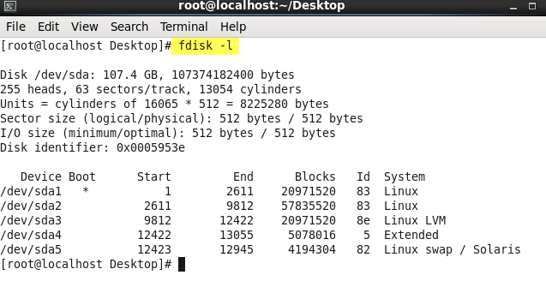

ii)‘**pvdisplay**’ shows the physical volume we have created.

Command:pvdisplay 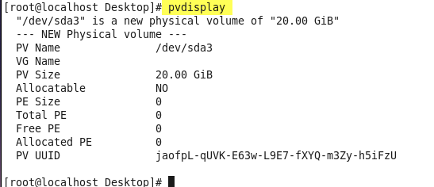

iii)Create volume group

Command: vgcreate <vgname> <lvm pv disk partition>****

iv)‘**vgdisplay**’ shows the volume group we have created.

Command:vgdisplay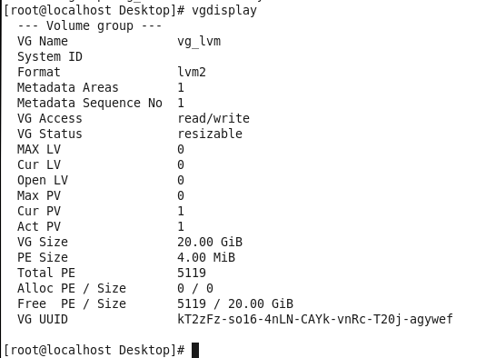

v)Create logicalvolume

Command: lvcreate -n <lvname> -L <lv space> <vg name>



vi)‘**lvdisplay**’ shows the logical volume we have created.

Command:lvdisplay 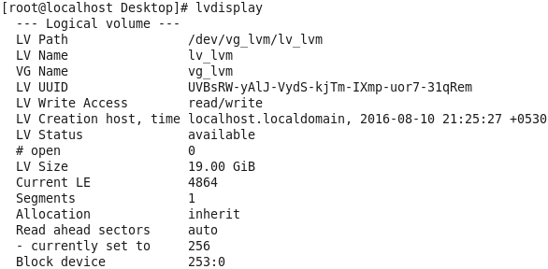

vii)List disk partitions

Command**:** fdisk -l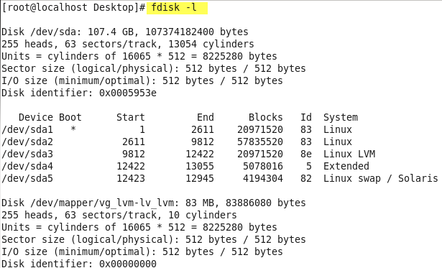

viii)Create lvm disk partition

Command**:** fdisk <lvm mapper path>

* Press n, then press p, and then press 1.
* Press Enter, and then press Enter again.
* Press w.

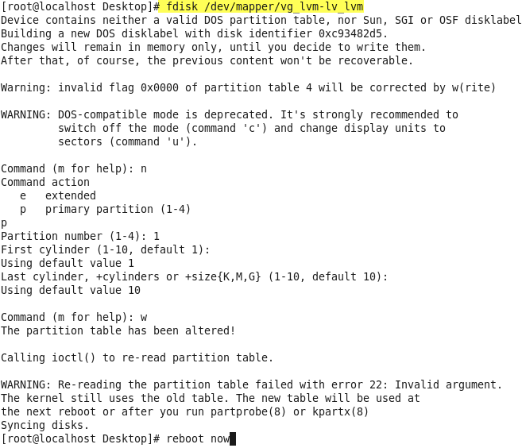

ix)Make file system

Command: mkfs.ext4 <lvm mapper path> 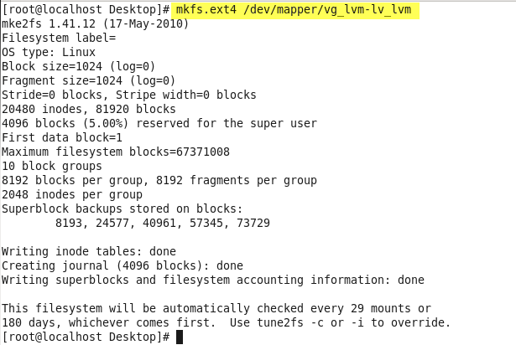

x)Edit targets.conf file and set

LVM server mapper path as backing-store and

client hostnames as initiator-address.

Command:vi /etc/tgt/targets.conf 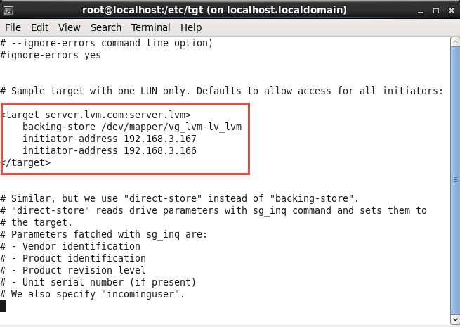

xi)Restart tgtd service

Command: service tgtd restart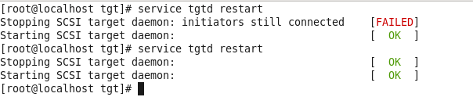

**On client1**

Now we need to do client configuration for LVM server. After the client server is ready with all the linux configuration done and hostname mapping being done

i)Restart tgtd service

Command: service tgtd restart 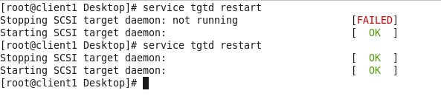

ii)Run the below command for restarting iscsi.

Command:

for i in iscsid iscsi; do chkconfig $1 on; service $i stop; service $i start; done 

iii) Discover targers

Command: iscsiadm --mode discovery --type sendtargets --portal <lvm server hostname> 

iv) Login to targets

Command:

iscsiadm --mode node targetname <target hosename> --portal <target hostname> --login



v)Check whether the shared drive is added or not.

Command:cat /proc/partitions

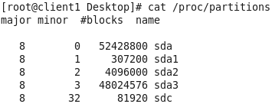

vi)Create disk partition

Command: fdisk /dev/sdc

* Press n, then press p, and then press 1.
* Press Enter, and then press Enter again.
* Press w.

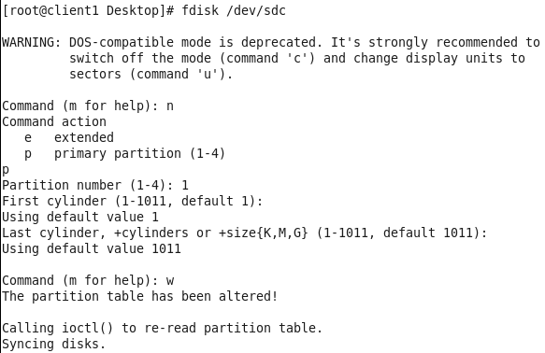

vii)Check whether the shared disk partition created or not.

Command:cat /proc/partitions

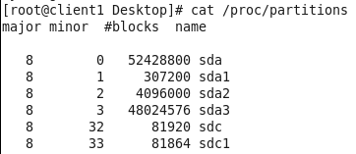

**Note:** Finish tasks on Client2 before making file system on Client1

viii)Make file system

Command: mkfs.ext4 /dev/sdc1 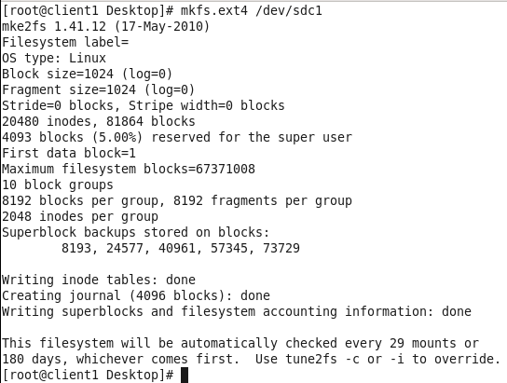

ix)Edit fstab file to append the following line to the /etc/fstab file:

Command:vi /etc/fstab

/dev/sdc1 /SANdisk1 ext4 rw,suid,dev,noexec,noauto,user,async 0 0

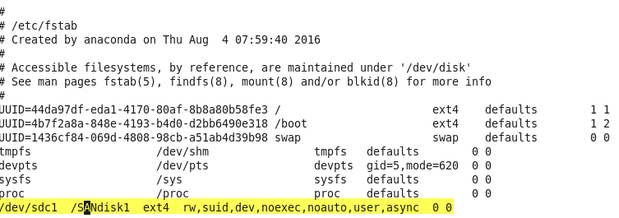

**On Client2**

Now we need to do client configuration for LVM server. After the client server is ready with all the linux configuration done and hostname mapping being done

i)Restart tgtd service

Command: service tgtd restart 

ii)Run the below command for starting iscsi.

Command:

for i in iscsid iscsi; do chkconfig $1 on; service $i stop; service $i start; done 

iii) Discover targers

Command: iscsiadm --mode discovery --type sendtargets --portal <lvm server hostname> 

iv) Login to targets

Command:

iscsiadm --mode node targetname <target hosename> --portal <target hostname> --login



v)Check whether the shared drive is added or not.

Command:cat /proc/partitions

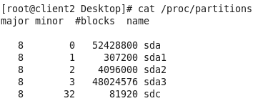

vi)On Client2, to scan a new disk partition that will create the /dev/sdc1 device

Command: partx -v -a /dev/sdc

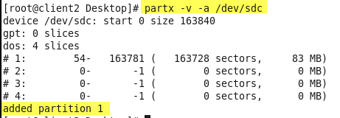

vii)Check whether the shared disk partition added or not.

Command:cat /proc/partitions

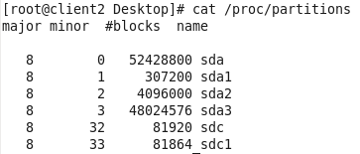

viii)Edit fstab file to append the following line to the /etc/fstab file:

Command:vi /etc/fstab

/dev/sdc1 /SANdisk1 ext4 rw,suid,dev,noexec,noauto,user,async 0 0 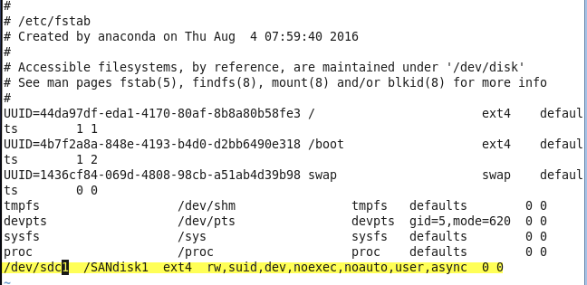

**Note:** After finished steps on Client2, continue to finish steps from viii) on Client1.

**Testing LVM functionality by file sharing**

On Client1:

i)Mount drive which we mentioned in /etc/fstab file

Command: mount <drive>

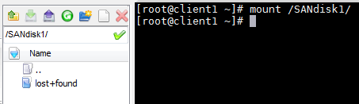

ii)Upload any file to that mounted drive

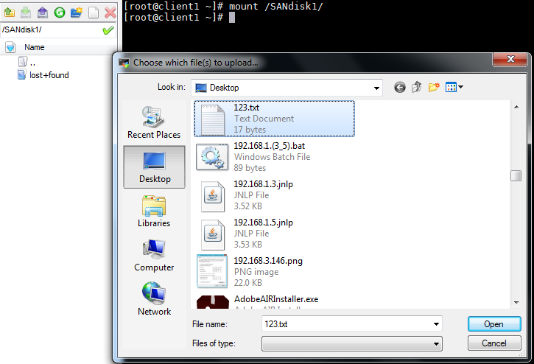

iii)Refresh the drive to display uploaded files

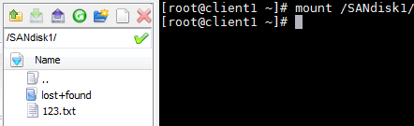

On Client2:

i)Mount drive which we mentioned in /etc/fstab file

Command: mount <drive>

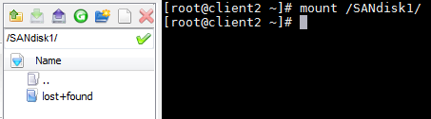

ii)Unmount and mount the drive to effect the shared drive files

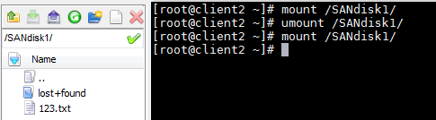

Note:Do the same testing on Client2 to share files from Client2 to Client1